NAME: INEX GORICA AD OHRID
Address: NAUM OHRIDSKI BR:5/7 OHRID
IBAN Code: MK 07250901000017783
Name of the bank: Sparkasse Banka Makedonija AD Skopje
Adress: Makedonija str.34,1000 Skopje, North Macedonia
SWIFT: INSBMK22

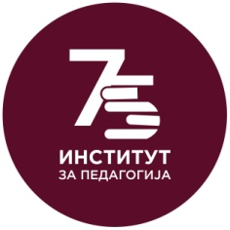

Hotel Reservation Form for the International Scientific Conference
"75th anniversary of the Institute of Pedagogy - Educational Challenges
and Future Prospects"

Customer: Mr./Ms. ________________________________________________________
Email:___________________________________ Phone:________________________
Arrival Date:_____________________________ Departure Date:_______________

Room Type Half Board (Breakfast & Lunch)
❑ Single room 45 Euro per person per night (max 1 person)
❑ Double room 90 Euro per room per night (max 2 persons)
Specific requirements: ___________________________________________________

Payment: Reservation for the hotel accommodation should be sent to the e-mail address marketing@hotelinexolgica.com.mk so that you can get detailed information about the payment method.

Cancellation politics:
The reservations for the accommodation shall be made only in writing in electronic form, and also the confirmation of the reservation is to be made electronically. The date of the written cancellation represents a basis for calculation and payment of cancellation charges (in terms of basic price of the arrangement) according to the following table:
•cancellation of reservation 30 days prior to arrival.................... no fees
•cancellation of reservation 10-19 days prior to arrival ..............30% of total amount
•cancellation of reservation 1-9 days prior to arrival ..................40% of total amount

*Booking Deadline until April 15th 2022

*Requirements: Vaccination certificate with two doses of the COVID-19 vaccine or negative PCR test for Covid 19

